Title: Service Delivery Operations Lead
Group: Tamariki & Whānau Services
Reports to: Chief Advisor – Office of the DCE
Location: National Office, Wellington
Direct Reports: No
Budget: No
PUBLIC SERVICE PURPOSE STATEMENT
Ka mahitahi mātou o te ratonga tūmatanui kia hei painga mō ngā tāngata o Aotearoa
i āianei, ā, hei ngā rā ki tua hoki. He kawenga tino whaitake tā mātou hei tautoko i te Karauna i runga i āna hononga ki a ngāi Māori i raro i te Tiriti o Waitangi. Ka tautoko mātou i te kāwanatanga manapori. Ka whakakotahingia mātou e te wairua whakarato ki ō mātou hapori, ā, e arahina ana mātou e ngā mātāpono me ngā tikanga matua o te ratonga tūmatanui i roto i ā mātou mahi.

In the public service we work collectively to make a meaningful difference for New Zealanders now and in the future. We have an important role in supporting the Crown in its relationships with Māori under the Treaty of Waitangi. We support democratic government. We are unified by a spirit of service to our communities and guided by the core principles and values of the public service in our work.

You can find out more about what this means at (https://www.publicservice.govt.nz/about-us)

OUR ORGANISATION
About us | Oranga Tamariki—Ministry for Children is a Ministry dedicated to supporting any child in New Zealand whose wellbeing is at significant risk of harm now, or in the future. We also work with young people who may have offended, or are likely to offend. Our belief is that in the right environment, with the right people surrounding and nurturing them, any child can, and should flourish.
Our vision | All children are safe, loved and nurtured by whānau, hapu, and iwi, supported by thriving communities.
Our purpose | We serve those children, young people, and families who come to our attention. We focus on keeping them safe and preventing them from coming into care or custody by ensuring the children’s system provides support to families.
Our three shifts
  Mana Ōrite | Shift decision making and resources by enabling communities
  Whakapakari Kaimahi | Enable our People
  Rato Pūnaha | Lead the System
Our values | 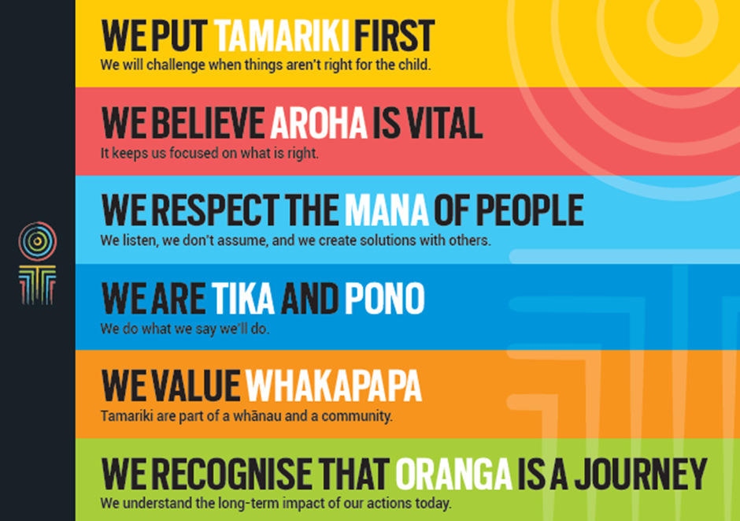

POSITION PURPOSE
Tamariki and Whānau Services provides care and protection, caregiver support, adoption services, National Contact Centre operations, Coordinators, and a range of specialist services to tamariki, whānau, carers, and those involved in adoption. This is achieved through direct support, service provision of partnered practices, national practice models and operational support.

The Service Delivery Operations Lead is responsible for establishing and overseeing a nationally coordinated system for workforce planning and management within Tamariki and Whānau Services. The system will draw on regional expertise, data and demand modelling, with a focus on optimising capacity across the country. This role works collaboratively with operational leaders to ensure Oranga Tamariki has the right mix of social workers, allied support workers and other roles, in the right locations, to meet regional service demands and deliver high-quality services to tamariki and whānau.

By leveraging insights, and designing and implementing systematic approaches to workforce planning, the Service Delivery Operations Lead will forecast workforce needs, monitor capacity, and identify opportunities to strengthen service delivery. The role will work closely with Regional Commissioners, site managers, and enabling functions such as People and High Performance and Finance, to project demand, optimise workforce deployment, enable more informed caseload management and strengthen our capacity to deliver quality social work for tamariki and whānau. The role will also bring influence and leadership skills, liaising with key enabling functions to drive a priority focus on the actions needed to strengthen workforce capacity and address any identified pressure points (e.g. in particular geographic locations).

In addition, the Service Delivery Operations Lead supports the Chief Advisor and the Tamariki and Whānau Services leadership team in delivering on the strategic priorities of the Deputy Chief Executive. The role may also lead or contribute to specific agreed projects and deliverables beyond workforce management that support the wider Tamariki and Whānau Services Group.
KEY ACCOUNTABILITIES
Key Result area | Key Accountabilities
Strategic Workforce Planning & Forecasting | - Develop and implement consistent, systematic national-level processes for monitoring and managing workforce capacity.  - Identify emerging workforce trends and develop strategies to ensure Tamariki and Whānau Services remains future-ready and responsive to changing service demands.  - Use the Strategic Workforce Analysis Tool and other sources of insight to anticipate demand, identify trends, risks, and opportunities for proactive workforce management.  - Collate, disseminate and interpret data and insights to enable senior national and regional operational leaders to make informed workforce resourcing decisions.  - Liaise with key enabling functions to ensure an aligned, prioritised and joined-up focus on strengthening workforce capacity and addressing identified areas of need.  - Understand how to align workforce capacity with service delivery needs across diverse regions.  - Provide strategic advice to leadership on workforce implications of service delivery changes, policy shifts, or emerging pressures.  - Support the strategic integration of Allied Support Workers into service delivery models to enhance workforce capacity and efficiency.  - Work closely with the Data Solutions team as the technical/product owner of the Strategic Workforce Analysis Tool to ensure it meets the evolving needs of workforce planning and delivers actionable insights.  - With the support of the Chief Advisor and others as required, play a lead role and developing advice for the DCE Tamariki and Whānau Services, Human Resources, Finance and Te Riu regarding strategic decisions relevant to the Tamariki and Whanau Services workforce.
Reporting | - Ensure accurate, timely, and meaningful reporting on workforce metrics, trends, and risks to support decision-making at all levels.  - Support transparency and accountability through regular reporting and documentation of workforce planning activities, outcomes, and challenges.  - Establish feedback mechanisms to ensure reporting outputs are continuously improved and remain fit for purpose.
Relationship Management and Communication | - Build, maintain, and leverage strong relationships with senior leaders, enabling functions, and other key stakeholders.  - Engage effectively across the organisation to support regional and national workforce planning, contribute to reporting and insights, and ensure alignment with service delivery priorities.  - Strengthen workforce systems and build capability by providing robust advice and practical guidance to operational leaders and teams.  - Ensure communications are timely, easily understood and meet the needs of the audience.  - Present complex information clearly and confidently to senior audiences, and tailor communication approaches to suit the needs of diverse stakeholders.  - Champion best practice across Oranga Tamariki by sharing insights, modelling effective behaviours, and fostering collaboration.
Continuous Improvement and Change Management | - Provide advice and analysis around anticipated workforce demands to senior operational leaders to plan for future needs.  - Identify and implement improvements to business policies, processes, and frameworks to enhance workforce planning and service delivery.  - Leverage data and analytics to identify opportunities for improvement and drive continuous enhancement of workforce deployment and service delivery.  - Lead or support change initiatives that improve workforce systems, data use, and operational practices.  - Promote a continuous improvement mindset by encouraging feedback, learning, and innovation across teams.  - Ensure change is well-managed and communicated, with appropriate support provided to leaders and staff during transitions.  - Help develop and maintain a culture within Tamariki and Whānau Services and the wider organisation that supports achieving and delivering strategic priorities.  - Support and contribute to evaluations of policies, frameworks, processes, and tools to ensure effectiveness, efficiency, and alignment with organisational goals.
Risk Management | - Monitor, escalate and provide advice as appropriate regarding emerging risks and trends that may affect workforce capacity, service delivery, or operational effectiveness.  - Contribute to the development and maintenance of risk registers and mitigation plans relevant to workforce operations.  - Identify financial, operational and organisational risks and take action to address them or minimise their impact.  - Work closely with the Chief Advisor and wider Tamariki and Whānau Services team to ensure that key system risks or issues that may impact tamariki, whānau, carers, or the Ministry’s reputation are appropriately understood, escalated, and addressed.
Project Management | - Support and, where appropriate, lead the development and implementation of operational, transformation, and strategic projects and programmes.  - Ensure all initiatives are aligned with and contribute to the strategic outcomes of Oranga Tamariki and Tamariki and Whānau Services.  - Deliver projects and programmes as needed, ensuring timely, on-budget, and high-quality delivery, with regular progress updates to stakeholders.  - Undertake other responsibilities, projects, or initiatives as required to support the goals of Tamariki and Whānau Services.
Mentoring and Leadership | - Create a supportive and positive environment, helping others develop and achieve, and acting in the interests of the full team.  - Contribute to building team capability by mentoring others, sharing knowledge, and encouraging continuous learning.  - Foster a culture of collaboration, accountability, and respect within the team and across the wider organisation.
Cultural Competence | - Champion, role model and encourage demonstration of Oranga Tamariki values.  - Actively incorporate tikanga Māori and te reo Māori into the day-to-day mahi of Tamariki and Whanau Services.
Being part of the Oranga Tamariki team | - Actively and positively participate as a member of the team  - Proactively look for opportunities to improve the operations of Oranga Tamariki  - Perform any other duties as needed by Oranga Tamariki  - Comply with and support all health and safety policies, guidelines and initiatives  - Ensure all incidents, injuries and near misses are reported into our H&S reporting tool  - Comply with all legislative and regulatory requirements, and report any breaches as soon as they become known  - Adhere to all Oranga Tamariki procedures, policies, guidelines, and standards of integrity and conduct  - Demonstrate a commitment to and respect for the Treaty of Waitangi and incorporate these into your work.

KEY RELATIONSHIPS
Internal | - Tamariki and Whānau Services Leadership team  - Regional Commissioners and their leadership teams  - Chief Advisors  - National Support Services  - People & High Performance  - Finance  - System Leadership, including Data Solutions  - Regional staff including Caregiver Recruitment and Support Managers, Operations Managers, Delivery Advisors Operational Support, Site Managers and Practice Leaders.  - Office of the Chief Social Worker and Professional Practice Group
External | - Other Government departments and agencies, education providers and professional bodies where appropriate

QUALIFICATIONS & EXPERIENCE
Qualifications | - Relevant tertiary qualification is desirable and/or significant practical experience in a similar role.
Other requirements | - Willingness to travel within New Zealand to fulfil the requirements of the role
Experience | - Experience in the social services sector or a related field is desirable.  - Significant experience in workforce planning, capacity monitoring, or operational service delivery in a complex environment.  - Demonstrated ability to use data and analytics tools to inform workforce decisions and drive continuous improvement.  - Strong experience in providing support and advice at a senior level.  - Extensive experience managing multiple projects simultaneously while effectively prioritising and balancing the needs of a diverse range of stakeholders.  - Adaptable and resilient, proven ability to remain effective and positive in a fast-paced, changing environment.
Skills | - Highly developed organisational skills, with the ability to manage a busy and diverse workload and deliver high-quality outcomes within tight timeframes.  - Excellent written and verbal communication skills, able to convey complex information clearly and tailor messages to different audiences.  - Confident using digital tools and technology to support workforce planning and service delivery.  - Strong relationship management skills; able to establish, build, and maintain effective working relationships at all levels of the Ministry and with key stakeholders.  - Results-oriented, with a strong commitment to achieving goals, generating innovative ideas, proactively solving problems, and taking initiative beyond immediate tasks.  - Effective problem-solving and decision-making skills; able to clearly identify issues, evaluate alternative solutions, assess risks and benefits, seek input from others, and make sound decisions.  - Highly developed research and strategic thinking skills, including the ability to analyse complex information, structure problems, and draw well-founded conclusions.  - Proven analytical skills, with experience assessing risks and drawing insights from data, insights, assurance, audit, or related assignments.  - Excellent interpersonal skills, adaptable to suit different audiences, able to influence others, and dedicated to effective teamwork.  - Understanding and appreciation of cross-cultural issues, with knowledge of tikanga Māori and Pacific peoples’ cultures.

