Title: Executive Assistant
Group: People Culture and Enabling Services
Reports to: Chief Advisor - Office of the DCE
Location: As specified
Direct Reports: No
Budget: No
OUR ORGANISATION
About us | Oranga Tamariki—Ministry for Children is a Ministry dedicated to supporting any child in New Zealand whose wellbeing is at significant risk of harm now, or in the future. We also work with young people who may have offended, or are likely to offend. Our belief is that in the right environment, with the right people surrounding and nurturing them, any child can, and should flourish.
Our vision | Our vision is: New Zealand values the wellbeing of tamariki above all else.
Our purpose | Our purpose is: To ensure that all tamariki are in loving whānau and communities where oranga tamariki can be realised.
The Oranga Tamariki way | We’ve introduced a new way of doing things. A way of looking at the world that guides everything we do:  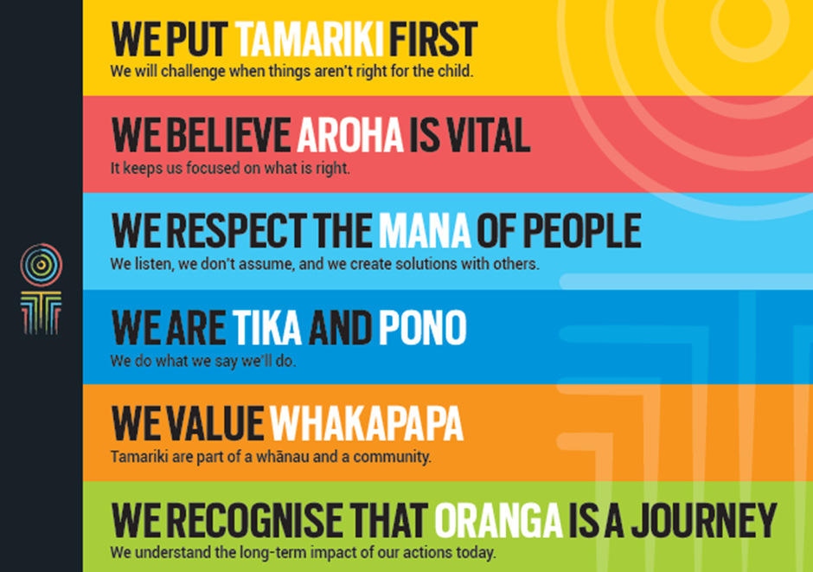
Our core outcomes | Our core outcomes are:  - All children and young people are in loving families and communities where they can be safe, strong, connected, and able to flourish  - Improved outcomes for all children, especially tamariki and rangatahi Māori.

POSITION PURPOSE
The purpose of the Executive Assistant is to provide a high level pro-active, quality and comprehensive executive assistant support to a manager, enabling them to undertake their role effectively and efficiently. This role will also assist with general and specific support duties to the wider team.
KEY ACCOUNTABILITIES
Key Result area | Key Accountabilities
Executive Support | - Administer the diary of the Manager in a way that allows them to undertake their responsibilities in a structured and planned manner.  - Manage incoming emails on behalf of the Manager and respond directly where appropriate  - Pre-empt the needs of the Manager to ensure that they are provided with the information and resources they need to prioritise, prepare and undertake their work activities in an informed way  - Act as a first point of contact for all the Manager’s enquiries, demonstrating sound judgement skills  - Answer telephone calls as required, handle internal client queries appropriately, and maintain effective relations with key stakeholders (both internal and external)  - Assist with monthly and ad hoc report production  - Assist in the preparation of strategic and annual business plans for the Group  - Arrange and co-ordinate Group and strategic meetings (and other forums) including agenda development, minute taking, report preparation and coordination, preparing presentations and arranging facilities, social events, accommodation and catering for each function  - Establish and maintain excellent relationships with stakeholders  - Provide a high standard of general executive assistant and administrative services  - Maintain a high level of confidentiality and prioritisation of all matters.
Financial | - Ensure invoices are coded correctly, accurately authorised at the appropriate level, and follow financial procedures and delegations  - Ensure invoices are forwarded to Finance in a timely manner so that they can be processed by the due date.
Travel | - Arrange travel, transport and accommodation for the Manager, making sure that policies are followed when bookings are made  - Arrange travel, transport and accommodation for other members of the wider team as and when required, making sure that policies are followed when bookings are made.
Being part of the Oranga Tamariki team | - Actively and positively participate as a member of the team  - Proactively look for opportunities to improve the operations of Oranga Tamariki  - From time to time, you may be required to perform other reasonable duties as requested by your manager  - Comply with and support all health and safety policies, guidelines and initiatives  - Ensure all incidents, injuries and near misses are reported into our H&S reporting tool  - Comply with all legislative and regulatory requirements, and report any breaches as soon as they become known  - Adhere to all Oranga Tamariki procedures, policies, guidelines, and standards of integrity and conduct  - Demonstrate a commitment to and respect for the Treaty of Waitangi and incorporate these into your work.

KEY RELATIONSHIPS
Internal | - Staff within the group and wider organisation  - Executive Assistants and other support staff  - Oranga Tamariki staff
External | - A range of external stakeholders on specific issues.

QUALIFICATIONS & EXPERIENCE
Qualifications | - Relevant tertiary qualification in secretarial/administration and/or business management
Experience | - Experience in providing executive support to manager.
Skills | - Excellent verbal, written and interpersonal communication skills  - Ability to communicate complex ideas to a variety of audiences and build and maintain rapport with others  - Understanding and appreciation of cross cultural issues and concerns, in particular, knowledge of tikanga Māori, and Pacific peoples’ culture  - High level of integrity and professionalism  - Ability to maintain confidentiality and discretion  - Strong organisational ability to optimise and prioritise conflicting demands in a busy environment, to achieve deadlines and see responsibilities through to completion  - Good analytical skills and attention to detail  - Computer literate; proficient in Windows 2000 or later, MS Word/Excel and other Microsoft Office applications  - Excellent self-management skills, including working effectively without direct supervision, managing and organising fluctuating workloads in sometimes stressful situations  - Able to personally cope with ambiguity and change  - A team player and considers the views of others.

