Title: Senior People and Performance Partner
Group: People, Culture and High Performance
Reports to: Manager People and High Performance
Location: Auckland or Wellington
Direct Reports: No
Budget: No
PUBLIC SERVICE PURPOSE STATEMENT
Ka mahitahi mātou o te ratonga tūmatanui kia hei painga mō ngā tāngata o Aotearoa
i āianei, ā, hei ngā rā ki tua hoki. He kawenga tino whaitake tā mātou hei tautoko i te Karauna i runga i āna hononga ki a ngāi Māori i raro i te Tiriti o Waitangi. Ka tautoko mātou i te kāwanatanga manapori. Ka whakakotahingia mātou e te wairua whakarato ki ō mātou hapori, ā, e arahina ana mātou e ngā mātāpono me ngā tikanga matua o te ratonga tūmatanui i roto i ā mātou mahi.

In the public service we work collectively to make a meaningful difference for New Zealanders now and in the future. We have an important role in supporting the Crown in its relationships with Māori under the Treaty of Waitangi. We support democratic government. We are unified by a spirit of service to our communities and guided by the core principles and values of the public service in our work.

You can find out more about what this means at (https://www.publicservice.govt.nz/about-us)

OUR ORGANISATION
About us | Oranga Tamariki—Ministry for Children is a Ministry dedicated to supporting any child in New Zealand whose wellbeing is at significant risk of harm now, or in the future. We also work with young people who may have offended or are likely to offend. Our belief is that in the right environment, with the right people surrounding and nurturing them, any child can, and should flourish.
Our vision | All children are safe, loved and nurtured by whanau, hapu, and iwi, supported by thriving communities.
Our purpose | We serve those children, young people, and families who come to our attention. We focus on keeping them safe and preventing them from coming into care or custody by ensuring the children’s system provides support to families.
Our three shifts
  Mana Ōrite | Shift decision making and resources by enabling communities
  Whakapakari Kaimahi | Enable our People
  Rato Pūnaha | Lead the System
Our Values | 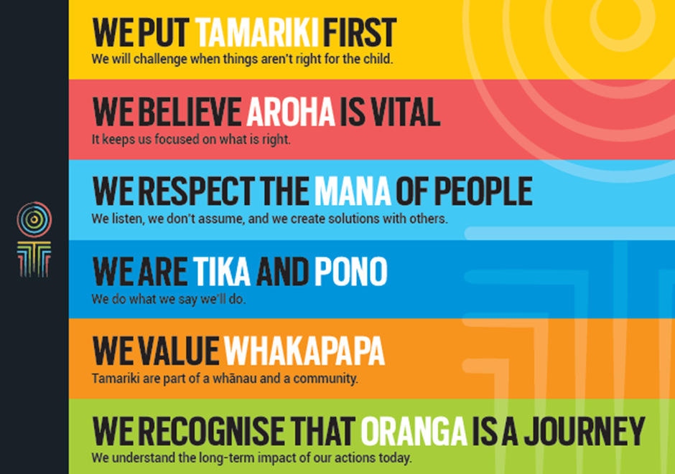

POSITION PURPOSE
Our desired future is one where we demonstrate that our people matter, and that we cannot realise our vision without them. We want our people to feel listened to, valued and empowered. We want to make things easy for them, to have the right skills, and feel supported to put tamariki first. We have three focus areas to support our people to live the Oranga Tamariki vision, purpose and the Oranga Tamariki way. These are:
- Make our people processes effective and easy so they can focus on oranga tamariki
- Build our capability so we can realise oranga tamariki
- Create an environment where our people are empowered to put tamariki first
The purpose of the People and High Performance team is to help our team to deliver on our people strategy by providing targeted advice, support and guidance to the managers on people-related issues and deliver an exceptional employee experience across Oranga Tamariki.
The Senior People and Performance Partner (SPPP) will work with the Manager People and High Performance to provide strategic and tactical people solutions to business needs. The role supports Deputy Chief Executives (DCEs) and their senior leadership teams to enhance capability and business performance outcomes. The SPPP supports the on-going development and implementation of the DCE Group’s workforce plan in line with Oranga Tamariki vision and strategy.
As a member of the People and High Performance team you will ensure an integrated approach to key initiatives in all areas of HR to ensure economies of scale, consistency and alignment with the overall strategic direction and performance objectives of Oranga Tamariki. With your in-depth knowledge of your DCE Group(s) and their workforce plan, you will work closely with the HR Operations teams to share information, monitor trends and enable the effective and timely operationalisation of key initiatives.
.

KEY ACCOUNTABILITIES
Key Result area | Key Accountabilities
People Partnering | - Develop and maintain in-depth understanding of your allocated DCE Group(s); their business objectives, challenges, risks and HR related indicators (such as establishment, workforce model, core roles)  - Determine how the HR function can support the business in being successful with an eye to the medium- and long-term future  - Problem solve and recommend solutions leveraging your experience, insights and access to knowledge across the Group and networks  - Help senior business leaders understand and plan for the people implications of business decisions  - Attend DCE Group leadership team meetings, providing strategic and tactical advice  - Work with the People and Performance Partner to monitor and report on key people metrics and trends for the DCE Group, utilising established reports and working closely with the HR Reporting and Analytics team  - Provide support for organisational change, ensuring we have a consistent approach across the business  - Provide guidance to the business group during business planning  - Partner with managers providing people support in:  - Promoting the relationship between line manager and employee as the primary employment relationship  - Work with the HR Operations teams to design and deliver relevant and practical HR solutions to develop and equip line managers for success  - Ensure HR initiatives and interventions are integrated across the business.  - Work with the Organisation Development team to come up with training and development to meet specific needs and build capability
Workforce Planning | - Assist the Manager People and High Performance to design, develop and implement focused Group workforce plans (focusing on capacity, capability, culture and change leadership) that are aligned with business goals and outcomes  - Provide a range of fit for purpose solutions to enable improvements or new initiatives which lead to efficiencies, enhanced capability, productivity, retention of talent and employment engagement  - Support managers to plan and work through organisational change including facilitating co-design approaches and developing business cases for change  - Work with the People & Performance Partner to support the operational aspects of organisational change including preparing documentation, collating feedback and general operational support  - Lead projects, initiatives and pieces of work in consultation with the Manager People and High Performance  - Work closely with the People & Performance Partner to ensure initiatives and interventions from the workforce plan are operationalised and integrated across the business as appropriate  - Monitor the implementation of any HR initiative and keep the business on track.
HR Advice | - Work in partnership with the People & Performance Partner to ensure the provision of timely, consistent coaching, advice and support on all aspects of HR to our people leaders. This includes performance management, recruitment, induction, employment relationship, remuneration, recognition and reward, leadership development and change management  - Ensure compliance with Oranga Tamariki HR policy and procedures, and legal requirements by helping management understand their HR risks and how to effectively manage them. Interpret policy and procedures consistently and objectively  - Contribute to the development of initiatives and improvements to current HR practices that foster an environment and culture where people development is a priority, enabling them to be motivated and supported to be their best practice and/or policy changes  - Support our people leaders to build a culture that is aligned with  - Oranga Tamariki’s values  - Work collaboratively to support key People, Culture and High Performance projects and share information  - Maintain awareness of current, pending and legislative developments related to employment.
Coaching and Mentoring | - Build effective relationships with our people leaders becoming trusted advisors so as to influence them in the execution of their people management responsibilities  - Improve HR understanding and lift the capability of People and High Performance staff and those who manage people through coaching, advice and support that adds learning and value  - Up-skill and develop people leaders, encouraging a culture of accountability, trust and self-sufficiency  - Promote and role model the values and goals for Oranga Tamariki including good employer principles and practices and expected high standards of integrity, ethics and behaviour in all operations of Oranga Tamariki.
Cultural competency | - Demonstrate understanding of, and commitment to, our Māori cultural framework.  - Proactively instil and strengthen knowledge and practice within own team and across People, Culture and High Performance  - Ensure there is regard to our Māori Cultural Framework and S7AA in our work, policies, practices and reporting.
Risk Management | - Identify any people related, reputational and/or organisational risks and take action to minimise their impact  - Effectively manage risks, escalating and proposing appropriate mitigation where necessary.
Being part of the Oranga Tamariki team | - Actively and positively participate as a member of the team  - Proactively look for opportunities to improve the operations of Oranga Tamariki  - Perform any other duties as needed by Oranga Tamariki  - Comply with and support all health and safety policies, guidelines and initiatives  - Ensure all incidents, injuries and near misses are reported into our H&S reporting tool  - Comply with all legislative and regulatory requirements, and report any breaches as soon as they become known  - Adhere to all Oranga Tamariki procedures, policies, guidelines, and standards of integrity and conduct  - Demonstrate a commitment to and respect for the Treaty of Waitangi and incorporate these into your work.

KEY RELATIONSHIPS
Internal | - DCE Leadership Groups  - People Culture and High Performance Team Members  - Finance Business Partner  - Legal team  - Other Oranga Tamariki kaimahi
External | - Workplace Representatives including unions  - External HR Services
QUALIFICATIONS & EXPERIENCE
Qualifications | - Tertiary qualification in Human Resources or related discipline or equivalent relevant experience
Other requirements | - Willingness to travel within New Zealand to fulfil the requirements of the role
Experience | - Demonstrated ability to work with the business to effectively execute business strategy  - Significant relevant experience in the HR disciplines  - Demonstrated ability to facilitate groups and lead projects  - Proven experience in leading/influencing in a comparably complex and sizable environment  - Ability to coach, and mentor people leaders and other People Culture and High Performance team members to enhance overall capability in HR practice  - Detailed knowledge of current NZ employment law and HR practices and can relate this to an organisational context.
Skills | - Sound and pragmatic judgement and approaches that are appropriate for the situation.  - Adept at managing multiple pieces of work and prioritizing the demands of a diverse range of stakeholders  - Ability to grasp complex business issues to contribute effective solutions to drive business success  - Excellent customer focus – you’ll delight in anticipating and meeting customer needs and be a superb relationship manager.  - High level written and oral communication skills with the ability to tailor for your audience  - You can convey information and ideas clearly to a broad range of people  - Strong organisational skills with the ability to multi-task, and work to tight and competing deadlines  - Satisfaction in delivering a job well done at pace - A good eye for detail  - An inclusive and approachable working style, you understand that diversity adds value.  - Understanding and appreciation of cross-cultural issues and concerns, in particular, knowledge of tikanga Māori, and Pacific peoples’ culture

